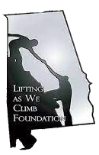
Lifting as We Climb Foundation
1955 HWY 33 P.O. Box 363 Pelham, Alabama 35124

August 16, 2021

Dear Community Partner:
Lifting as We Climb Foundation is pleased to announce its partnership with the Beta Mu Nu Chapter of Omega Psi Phi Fraternity, Inc. in hosting the 2021 Beta Mu Nu “8 vs 80” Golf Challenge. The Challenge will be held on October 15, 2021 at the Oak Mountain Golf Course, in Pelham, Alabama. The Beta Mu Nu Chapter has agreed to host this Golf Challenge on behalf of the Lifting as We Climb Foundation to raise funds to support the foundation’s charitable activities. We invite you to be a part of this event which is an excellent opportunity to promote your business as a sponsor.
Lifting as We Climb Foundation is a 501(c)(3) non-profit organization that was founded with the mission "Uplifting, empowering, and exposing youth in our community to positive environments and to encourage academic excellence, community service, and health awareness.” Our mission is based on the understanding that our future lies in the hands of our youth.
Knowing this we try and provide sound positive leadership, by example, is our aim through the four basic principles: Manhood, Scholarship, Perseverance, and Uplift.
Lifting as We Climb Foundation is an all-volunteer charitable organization that focuses on uplifting our communities through various programs. Our aim is to help our community and the disadvantaged youth in our community, realize their dreams through mentoring and
educational awareness.

Please consider supporting this event by registering at http://www.omegalawcf.org to participate as a sponsor, player, or spectator. Please see the attached sponsorship package.

Thank you in advance for your consideration and support.

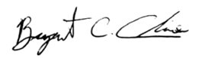
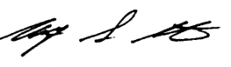
Sincerely,

Bryant C. Cline, President Anthony Overton, Chairman

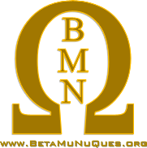
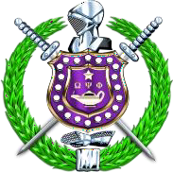
Beta Mu Nu Chapter of Omega Psi Phi Fraternity, Inc
1955 HWY 33 P.O. Box 832 Pelham, Alabama 35124
Re: Request for Sponsorship Support- 2020 Beta Mu Nu “8 –vs– 80” Golf Challenge
To Whom It May Concern;
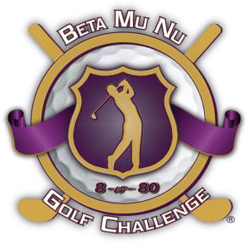
On behalf of the Lifting as We Climb Foundation, a 501c3 nonprofit organization, the Beta Mu Nu Chapter of Omega Psi Phi, Fraternity, Inc. is requesting your support for our 2020 Beta Mu Nu “8 –vs– 80” Golf Challenge being held on October 15, 2021 at the Oak Mountain Golf Course, in Pelham, Alabama.
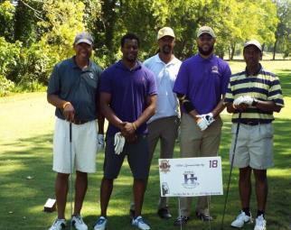
The Lifting as We Climb Foundation’s (LAWCF) goal for this event is to continue to shed an aspiring light within the community as we raise funds that benefit the foundation’s efforts to provide annual
scholarships, school supplies, and charitable donations to families in need, as well as champion the causes of a multitude of other worthy entities through our “Health Initiatives” and Community Outreach campaigns.
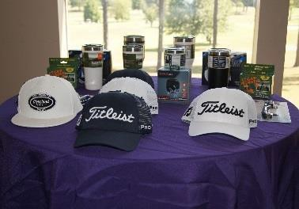
Our efforts include financial and service contributions to the following groups and causes:
• Children Village Birmingham
• Black Rhinos of Alabama Mentoring Program
• American Heart Association
• American Foundation for Suicide Prevention (Alabama Chapter)
• Community Blood Drives, Voter Registration Drives & Much More.

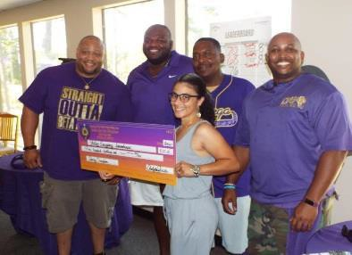
To make the 2021 Beta Mu Nu “8 –vs– 80” Golf Challenge the fund- raising success for worthy causes it is intended to be, we are asking for organization to secure a $500.00 sponsorship through monetary donations or in-kind services. Enclosed is the Registration Form for the event which details the Sponsorship Packages.
The Lifting as We Climb Foundation, 501c3 nonprofit, with assistance from the Men of the Beta Mu Nu Chapter of Omega Psi Phi Fraternity, Inc. are committed to giving back to the community and we thank you and your organization for your continued efforts in servicing, supporting, and uplifting the community. We pray that we can continue to build a bridge from your organization to ours for years to come.

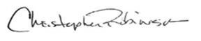
Sincerely,

Anthony Overton Christopher Robinson
Golf Tournament Chairman Honorary Tournament Chairman

